SCCS Math Homework 11/18/12

(you may NOT use a calculator)

1. Find the sequence and fill in the blanks

           (2, 3), (4, 6), (6, 9), (8, 12) ....  
           The 8th group is (__, __)

1. 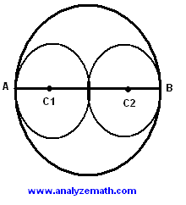In the figure beside, AB is a diameter of the large circle. The centers C1 and C2 of the smaller circles are on AB. The two small circles are congruent and tangent to each other and to the larger circle. The circumference of circle C1 is 8Pi. What is the area of the large circle?

.

1. Megan wrote down all of the three-digit numbers that can be written using each of the numerals 1, 2, and 3 exactly once. What is the average of the numbers that Megan wrote?
2. A woman drives from a CVS 3 miles north, 8 miles east, and then 3 miles north to her house. How far is it from the CVS to her house in miles?